# **Title: Enhancing Learning through Gamification: Applying Goal-Setting Theory in IVR**

Table of Contents

**Title: Enhancing Learning through Gamification: Applying Goal-Setting Theory in IVR** 1

INTRODUCTION: Background Introduction and context of the research topic 2

METHODOLOGY: 2

Game Design and Development: 2

Testing and Evaluation: 3

Feedback and Iteration: 3

Data Analysis 3

REVIEW OF LITERATURE: Summary of studies, articles, and books related to the topic. 3

Workplace Learning 3

Serious games and Game based learning 4

Designing Serious Games for education: from Pedagogical principles to Game Mechanisms (2011) 4

Engaging Students in the Learning Process with Game-Based Learning 5

Methods of learning 5

FINDINGS: Integration and synthesis of the main findings from the reviewed literature. 8

GAPS AND LIMITATIONS: 9

Development of project 9

Game tasks 10

Visual design 16

Feedback mechanisms 17

Results 17

CONCLUSION: 21

REFERENCES: # 22

## INTRODUCTION: Background Introduction and context of the research topic

The rapid advancement of technology, particularly in the realm of virtual reality (VR), has opened new avenues for innovation in various sectors, including workplace safety training. Traditional safety training methods, while informative, often struggle to fully engage learners or provide practical, hands-on experience in a risk-free environment. This research project explores the potential of Immersive Virtual Reality (IVR) to revolutionize safety training, with a specific focus on integrating Goal-Setting Theory to enhance learner engagement and effectiveness.

The COVID-19 pandemic has accelerated the need for digital solutions in training and education (Karakose et al., 2021)., highlighting the importance of technologies that can provide immersive, interactive learning experiences remotely (Pather et al., 2020). IVR offers a unique opportunity to create realistic, safe environments for trainees to practice and apply safety procedures without real-world risks. This technology aligns well with the principles of experiential learning and has shown promise in various educational and training contexts (Suh & Prophet, 2018; Vats & Joshi, 2024; D. W. Carruth, 2017; Sitterding, 2019).

However, the mere use of the novel technology does not guarantee improved learning outcomes. This is where Goal-Setting Theory, as proposed by Locke and Latham (2015), comes into play. By incorporating clear, specific, and challenging goals within the IVR environment, we aim to enhance motivation, focus attention, and improve overall performance in safety training tasks.

This research project specifically addresses the question: "Can integrating Goal-Setting Theory into an immersive virtual reality (IVR) environment enhance learner engagement and effectiveness in site safety training?" To explore this, we have developed a series of IVR modules that simulate various workplace safety scenarios, each designed to target different cognitive levels based on Bloom's Taxonomy (Anderson et al., 2001).

Through this study, we aim to contribute to the growing body of knowledge on the application of IVR in educational contexts, with a particular focus on its effectiveness in safety training. By examining how Goal-Setting Theory can be effectively implemented in IVR environments, we hope to provide insights that can guide the development of more engaging, effective, and personalized safety training programs in the future.

## METHODOLOGY:

### Game Design and Development:

With this research topic I aim to create a small-scale demo of a gamified environment of a site safety training, which teaches the correct safety rules for a site.

* The game will take form as an Immersive Virtual reality (IVR) environment, the game will take the user through a training course where they will need to demonstrate they know the dangers of where they are working.
* The user will have to complete the game to be inducted into the site, it will need to be up to date with safety procedure and easily suitable for the target demographic.
* The goals will be clearly displayed with a clear audio and visual update with each goal attained.
* It will be done by collaborating with professional in the field of electrical to ensure the game is realistic and suitable for teaching.

### Testing and Evaluation:

To begin a simple discussion with the participants about what the test is for will take place, then the game will be played, a quiz will be given to see if they can remember the hazards and other safety information from the project.

* Have the participants play the experience and monitor their progress and interactions with the game.
* After the game session, give a test then analyse the results to evaluate the effectiveness of the game in teaching site safety.

### Feedback and Iteration:

From Playtest and feedback this paper will collect feedback from the participants about their experience with the game. This will include their thoughts on the game mechanics, the difficulty level, the integration of the educational content, etc.

This feedback will be used to iterate on the game design. Making necessary adjustments to improve the learning experience and the enjoyment of the game.

### Data Analysis

Data will be collected and stored during the testing and evaluation stage. Following this, the test results and feedback are analysed to draw conclusions about the game’s effectiveness in teaching the site safety rules and trends in the data will be examined to guide future decisions in game design.

Data will be stored ethically and be anonymous, for the teaching elements the data will follow a quantitative, while for the gameplay adjustments a short qualitative text box will be provided.

## REVIEW OF LITERATURE: Summary of studies, articles, and books related to the topic.

### Workplace Learning

In the 1990s, some researchers started to question if schools and universities are the only places where people can learn. They suggested that learning can happen in other places too, such as the workplace. This idea was discussed in a book by Lave and Wenger’s (1991) their book on “situated learning” created a research topic that is still relevant today offering up a concept of communities of practice. Communities of practice contain the relevant knowledge of certain fields such as trades.

One of the advancing technologies is the development of Virtual Reality (VR) (Ayoung Suh, Jane Prophet, 2018). This technology can create realistic simulations for training and education. An area that is ready to be explored is practical tests and activities, which would typically be costly and time-consuming to moderate. If we can situate learning in an immersive and realistic virtual environment, we can actively engage learners to demonstrate their knowledge in a practical environment (Ayoung Suh, Jane Prophet, 2018.)

One of the key advantages of using VR to teach is its ability to engage learners on a deeper level (Vats, S., Joshi, R. 2024) (Hafsia, M, 2024). Traditional teaching methods often fail to capture and maintain people’s attention. However, according to Vats and Joshi (2024), VR technologies have the potential to enhance student engagement, facilitate immersive learning experiences, and improve knowledge retention. In Sitterding (2019) they found that VR training in nursing was more effective than traditional methods, providing a safe environment for practicing critical skills without real-world risks.

### Serious games and Game based learning

Taking a look into where the concept of Serious Games started, it was first introduced by Clark Abt in his seminal book ‘Serious Games’ (Abt, C.C., 1987), serve as the foundation of serious games. That games can be not merely sources of entertainment but also tools for explore more serious topics, they can be designed for education and learning new topics. That approach aligns with the principles of game-based learning (GBL) as proposed by James Paul Gee (Gee, J.P., 2003) which serves as a cornerstone for GBL. However, Gee also cautions that games, while effective for learning new systems, can potentially undermine confidence if poorly designed. This is a critical consideration in the development process of such games. While these papers are cornerstones of serious games and GBL it is important to keep in mind that they are outdated and there has been substantial research into the field since then.

### Designing Serious Games for education: from Pedagogical principles to Game Mechanisms (2011)

Designing Serious Games for education: from Pedagogical principles to Game Mechanisms (2011), in this paper they give reference to a framework for serious game design, they state that it should be deeply rooted in proper educational foundations to be effective, While the current paper advocates a ‘learning first, game second’ approach, this contrasts with the findings from previous research examined, which predominantly supports a ‘game first, learning second’ approach, however it does offer up some substantial findings from “game design patterns” in which they reference some of them by Kiili (2010).

* Integration Patterns: These are solutions that integrate game elements and learning objectives in meaningful ways, forming the foundation of educational game design.
* Cognition Patterns: These are solutions that stimulate reflective and metacognitive processes in players, helping them process relevant content experienced through gameplay. The effectiveness of gameplay is often linked to how quickly a player can understand and respond to cognitive feedback; this often links back to the Kolb cycle of learning.
* Presentation Patterns: These ensure effective content processing by the player. They involve extracting relevant information from a game world and integrating it into a coherent representation. The challenge lies in managing the cognitive load to prevent hindering learning, over simulating players with world information can lead to confusion.
* Engagement Patterns: These are solutions that motivate players to perform better in a game, facilitate learning, and increase playing time, thereby enhancing the overall gaming experience.

The paper emphasizes the role of a clean, well-designed interface in enhancing the appeal of a game. Such an interface can potentially increase accessibility and invite demographics that typically show aversion to instructional activities. The aesthetics and usability of the interface are suggested to significantly contribute to the success of a game-based learning tool.

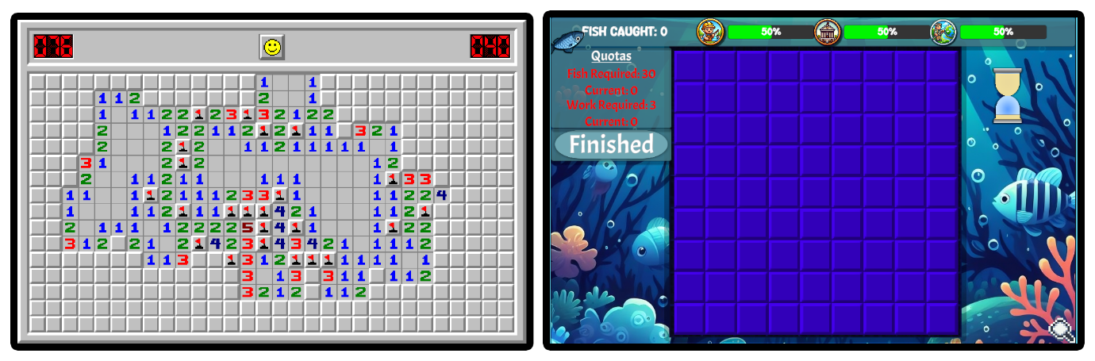

(Figure 1, showing an uplifted minesweeper)

However, the paper also cautions designers about the placement of aesthetic upgrades. It advises against cluttering or interfering with the main objective. One proposed solution is to display objects according to their salience, which is one of the considerations we will be taking when design modules.

Furthermore, the paper extends its discussion beyond visuals. It suggests that appropriate audio, in line with visuals, can enhance the learning experience. Thus, it’s not just the graphics, but also the sound design that can play a pivotal role in the game’s effectiveness.

In summary, the paper states that every aspect of the game - from visual presentation and sound design to user interface - is vital for the success of a game-based learning tool.

### Engaging Students in the Learning Process with Game-Based Learning

In a similar way to Designing Serious Games for education: from Pedagogical principles to Game Mechanisms (2011) this paper also offers a sweep of the theoretical underpinnings of GBL models. Rather than proposing patterns this papers approach offers theories similar to patterns.

* Narrative-Centered Learning Theory: This theory, proposed by Rowe et al. (2015), suggests that game-based education depends on the formation of narratives. It emphasizes the assimilation process where students are immersed in a compelling environment and time.
* Problem-Solving Theory: This theory highlights the importance of problem-solving abilities in today’s dynamic world.
* Engagement Theory: This theory argues that students retain concepts better when they are more involved in the learning process.

The theory outlines three concepts to enhance student engagement: emphasizing collaboration, adapting the learning process to project-based activities, and assigning tasks that are authentic and relevant. Both papers generally concur that optimal learning occurs when individuals are actively engaged with the environment and the problem at hand. A significant challenge identified is the creation of a problem space conducive to problem-solving. The design principles for this paper will attempt to incorporate these principles by placing the player in the shoes of a worker and having them solve/highlight issues, looking back to the previous paper incorporating audio and crisp visuals may make the player feel more engaged.

### Methods of learning

In contrast to traditional methods, games offer a broad spectrum of interaction. When evaluated using Bloom’s Taxonomy (1956), it becomes evident that the majority of paper-based methods reach a certain stage and then remain static. On the other hand, games provide a dynamic approach, allowing for a gradual progression through the stages of learning. This flexibility in navigating the learning process underscores the potential advantages of game-based learning methods over more rigid, traditional approaches. it is important to note that there has been an updated taxonomy to make it more relevant and to address some issues the older paper had (Anderson, L.W., and Krathwohl, D.R., et al, 2001). There are six stages in bloom taxonomy, and they are hierarchical with each stage a better understanding.

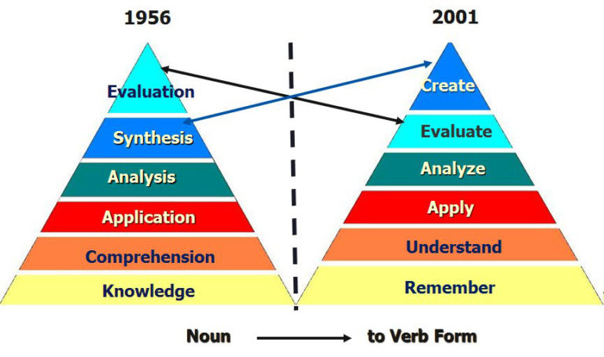

(Figure 2, Wilson 2020, showing the newer updated taxonomy)

In their study, Zainuddin, Zamzami, Alba, Amru, Gunawan, et al. (2022) aimed to construct a scale and identify factors influencing the implementation of gamification and Bloom’s Digital Taxonomy-based assessment in student learning. Their investigation was guided by the Goal-Setting Theory a theory proposed by Locke and Latham (2015) then expanded on in their new paper, they propose the importance of setting specific and challenging goals, that enhance motivations and performance, their research suggests that clear goals can direct individuals’ attention and efforts towards activities. This has been agreed within the field of psychology like (Csikszentmihalyi 1975) studies on flow, which is based on intrinsically motivated behaviours. In (Nakamura, J. and Csikszentmihalyi, 2002) they state some of the conditions that should be followed in a game to begin entering flow state.

* A player performs an activity that requires them to use a skill.
* That activity provides clear and close goals with immediate feedback and progress.
* The outcome is not determined but is directly influenced by the players actions.

While individual learning processes and paces vary, research has been conducted to categorize learning style models. One of the cornerstones of this research is a prominent model is that proposed by David Kolb in (Kolb, 1984). Kolb developed a theory suggesting a four-stage learning cycle alongside four distinct learning styles.

This theory which he called Kolb’s Experiential Learning Theory (ELT) states that learning is a progress where knowledge is created through experiences. Kolb originally identified four stages in the learning cycle:

* Concrete Experience: This is the stage where the learner actively experiences an activity.
* Reflective Observation: The learner consciously reflects back on that experience.
* Abstract Conceptualization: The learner attempts to conceptualize a theory or model of what is observed.
* Active Experimentation: The learner is trying to plan how to test a model or theory or plan for a forthcoming experience.

Alongside these stages, Kolb also originally proposed four distinct learning styles, with two styles (Active and passive):

* Diverging(Passive): These learners prefer to observe rather than take action, they are able to view concrete situations from multiple perspectives.
* Assimilating(Passive): These learners require a good clear explanation rather than a practical opportunity, they excel at understanding wide-ranging information and organizing it in a clear logical format.
* Converging(Active): These learners can solve problems and will use their learning to find solutions to practical issues, they prefer technical tasks, and are less concerned with people and interpersonal aspects.
* Accommodating(Active): These learners are ‘hands-on’, and rely on intuition rather than logic, they use other people’s analysis, and prefer to take a practical, experiential approach.

It is worth noting that there has been more research into the topic and there have been new insights (Kolb, David & Kolb, Alice, 2013), which introduced more diverse styles of learning, this was developed in response to some criticism with the model previous proposed by Kolb, which stated that the original proposal was limiting.

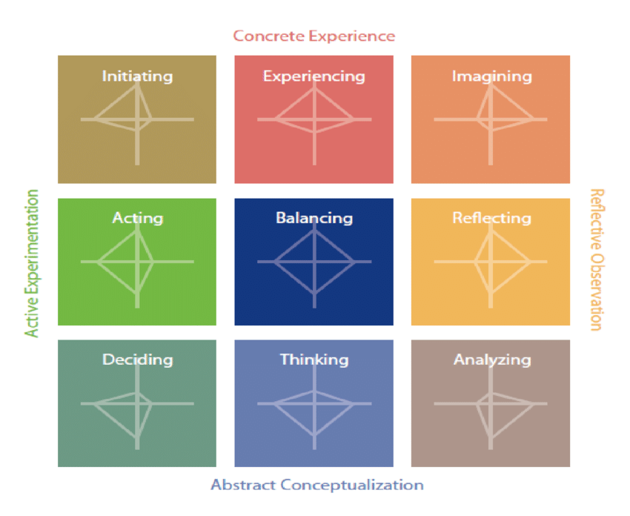

(Figure 3. Kolb, David & Kolb, Alice, 2013, showing the new version),

This can be integrated with other models like goal setting to motivate layer goals for what they hope to achieve within the cycle.

## FINDINGS: Integration and synthesis of the main findings from the reviewed literature.

Breaking down the literature review into segments reveals what relevant information can be gathered and applied onto the design and development of this research project.

Intrinsic Motivation: Goal-Setting Theory (Locke & Latham, 2015) highlights the role of specific, challenging goals in enhancing motivation and performance. In educational games, clear and attainable goals can foster intrinsic motivation (Nakamura, J. and Csikszentmihalyi, 2002), making them effective tools for learning. This theory supports the idea that integrating goals into gamified learning environments, such as IVR, can improve engagement and learning outcomes, learning is more effective when intrinsic motivation is present, the design of this project needs to keep that in mind, how do you make something intrinsic without being forced? Is another good question that may need answering. For this project I’m going to be taking the classic approach of using scores and numbers to reward the player, however how effective that may be may depend on the type of learner, I proposal that this proposal will be more effective with the hands-on learner type.

Design Principles: Research on Serious Games and Game-Based Learning (Abt, 1987; Gee, 2003) highlights that games can be powerful educational tools when designed with thoughtful alignment between game mechanics and learning objectives. The framework provided in "Designing Serious Games for Education" (2011) emphasises the importance of integrating thoughtful design with engaging game mechanics, cognitive stimulation, effective presentation through well-designed interfaces and environments. To that end the artefact will be designed so that the environment will be relevant to what an assumed end user might be training for and breaking it down into modules to lessen the cognitive load.

IVR Applications: Immersive Virtual Reality (IVR) has been shown to provide realistic and interactive training environments (Carruth, 2017; Cooper et al., 2021). and (Sitterding, 2019). IVR’s immersive nature can support Goal-Setting Theory by allowing learners to experience and practice skills in a simulated environment with immediate feedback, enhancing motivation and learning effectiveness.  
For this proposal, learners could practice hazard identification in a virtual worksite before applying these skills in real situations. IVR enables the creation of realistic simulations that replicate actual work conditions this approach ensures that learners are well-prepared for real-world applications by actively engaging in practical, hands-on training scenarios.

Engagement through VR: Studies by (Vats and Joshi, 2024; Hafsia, 2024) confirm that VR can significantly enhance learner engagement on deeper levels by providing immersive experiences. This aligns with the application of Goal-Setting Theory in IVR, where clear goals and interactive elements can drive motivation and improve learning outcomes. Kolb’s Experiential Learning Theory (1984; Kolb & Kolb, 2013) and Bloom’s Taxonomy had (Anderson, L.W., and Krathwohl, D.R., et al, 2001). highlights different stages of learning. Integrating these models into gamified IVR environments with different levels of learning engagement could facilitate more effective skill development through active engagement and reflection.

After looking at all of the research, the question originally proposed “Can integrating Goal-Setting Theory into an immersive virtual reality (IVR) environment enhance learner engagement and effectiveness in site safety training “brings up new questions like.

* How do you make something intrinsic without being forced?
* What learner type responds best to VR based learning?
* Are players aware of the different levels of cognitive complexity?

The questions highlighted greens are ones that I will be including in the questionnaire part of this proposal, while the one in red needs a much larger scale study than what this attempt to accomplish.

## GAPS AND LIMITATIONS:

Firstly, the sample size of this study (n=8) is notably small, which significantly limits the generalizability of our findings. This constraint was primarily due to the limited availability of VR equipment and the time-intensive nature of individual testing sessions. The small sample size restricts the ability to draw definitive conclusions about the effectiveness of our approach across diverse populations, however we have a majority of the right demographic.

Another limitation the time constraints of this project (approximately three months) limited the scope of our investigation. This prevented us from conducting longitudinal studies that could have provided insights into the long-term retention of safety knowledge and skills acquired through our IVR training. Additionally, it restricted our ability to iterate on the design based on user feedback, which could have potentially improved the overall user experience and lead to better learning outcomes.

Also, novelty of VR technology to many participants (37.5% had no prior VR experience) may have introduced a novelty bias. This could have inflated engagement scores and potentially masked usability issues that more experienced VR users might have identified. However, a benefit might be that they can identify issues with the new user experience.

There may be a potential Bias in the Self-Reported Learning Styles since it relies on self-reported learning styles which may introduce bias, as participants' perceptions of their learning preferences may not accurately reflect their most effective learning methods.

Despite these limitations, the study could provide a foundation for exploring the potential of IVR and Goal-Setting Theory in enhancing safety training.

## Development of project

To start, my goal was to develop a straightforward environment for testing VR interactions and exploring how VR development contrasts with traditional game development. In designing this space, I aimed to create a realistic workplace setting where users could apply the knowledge gained from this project. Research indicates that training environments mirroring real-world scenarios can enhance efficiency and learning outcomes (Cooper et al., 2021). This study highlights the use of visual and sensory cues to reinforce correct behaviours. I’ve taken some inspiration from the use of feedback cues, and made interactive object have some kind of feedback response.

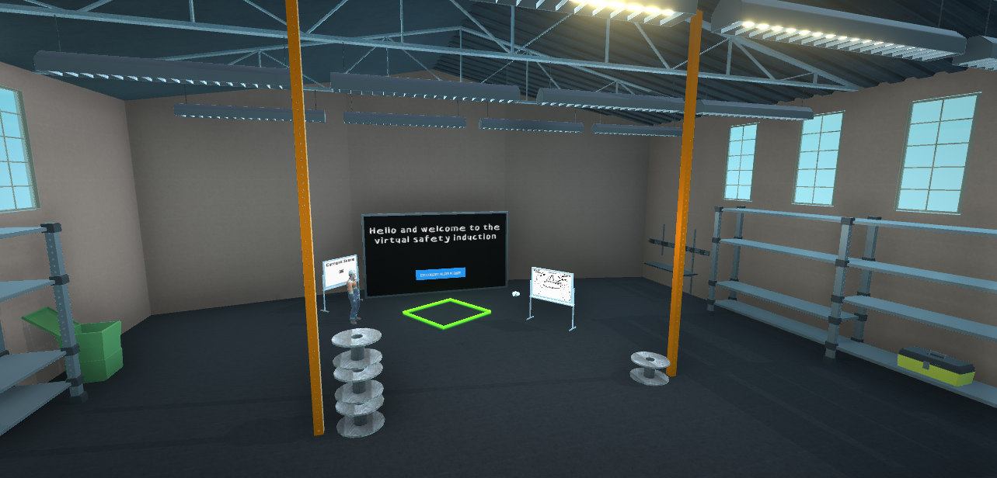

(Image of the main area, showing its warehouse appearance)

after getting to understand how VR interactions worked I wanted to create five learning experiences each with a different stage of the bloom taxonomy to allow for different levels of learning skills being applied, allowing for some easier tasks such as remembering information, then having tasks requiring the player to act on that information, and finally for them to evaluate situations, showing a higher level of understanding something that the traditional tests may not be able to clearly do.

### Game tasks

#### Design

Based on the toolbox talks and documents provided by industry professionals, I have crafted scenarios that simulate realistic workplace situations for interactive play rather than the traditional broad discussion. It has been shown that IVR has the potential to make workers faster and better at their job (Donovan, 2018) so the aim of this initiative is to create a more effective and engaging method for learning safety training procedures compared to traditional methods. This is important research because traditional training techniques often become monotonous and may not fully engage learners. By using an interactive style of safety training, we aim to enhance both retention and application of safety procedures. Interactive training can potentially improve memory recall and comprehension, as it allows learners to actively participate and apply their knowledge in a simulated environment, rather than passively receiving information.

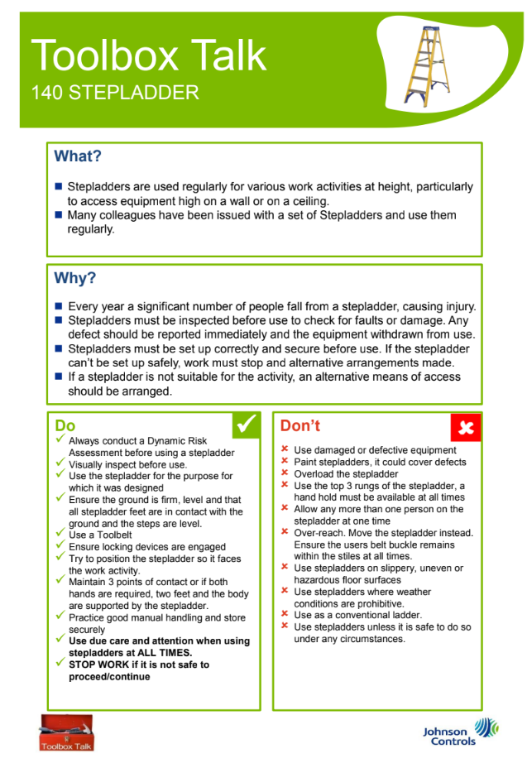

(Image of a toolbox talk, relating to stepladder uses, Jonson controls, no date)

From these general toolbox talks I looked into what could I implement into an interactive experience and then how to best teach the information, I looked into other IVR safety training modules such as (Sentient, 2016) and (Purdue Envision Center, 2019) and I noticed that they weren’t very intractable, and they slotted into the more conventional listen and repeat style of learning.  
So to differentiate mine I created a more open world environment where the player can move around and interact with objects in a physical virtual environment that can take advantage of situations which may require the player to find and look around before proceeding, This design caters to hands-on learners, following the Kolb Learning Cycle, by providing an open-world experience that encourages active participation, which I believe my application will appeal to.

I noticed that other IVR safety training programs effectively communicated safety rules with clear and well-paced voiceovers, and by using a human figure. I used this as a model for improving the clarity and timing in my own training, they also made good use of clear visual guides and displays.

For each task room, I employed the presentation patterns to learning efficiency. I designed each room to be appropriately sized for the module’s requirements and included only essential elements to reduce visual clutter. This approach ensures that the users interact only with relevant objects or deliberately incorrect ones, which helps support their focus. From my previous research having good visual presentations (Ott, Michela & De Gloria, et al 2011) leads into having clear cognition patterns, I incorporated several key principles into the design of each of the task rooms:

* Cognitive Load Management: I broke down the simulation into smaller, manageable modules to prevent overwhelming users. This approach allows for gradual learning and reduces cognitive overload, this also allows for them to quit and return later to complete the module rather than having to finish the simulation all in one go.
* Scaffolding: I included guided interactions cues and hints within the environment, the idea of a toolbox talk isn’t to fail but to be able to safely ask questions and understand what the risks are, so when designing I made sure that there were no hard fails or tension inducing elements such as timers, which is core to the design of being able to stop and come back to any of the modules.
* Situated Learning: The rooms are designed to mirror real workplace environments where users might apply the training, making the experience more relevant and contextual.

So, the application was designed to avoid fail states, ensuring that the primary focus remains on teaching rather than penalizing mistakes. The environment is intentionally structured to guide users through the learning process without the possibility of failing or getting stuck.

For example, if users answer only 8 out of 10 questions correctly, they are not penalized but rather encouraged to reflect on the missed answers and taken back to the start of the quiz module where they can choose the correct answer. This design choice ensures that the player remains engaged and motivated to complete the simulation, reinforcing learning through positive reinforcement and continuous improvement. The aim is to create a supportive learning environment where users can explore and learn from their interactions, ensuring that they complete the training and acquire the necessary knowledge.

The design and implementation of the game tasks in this study were guided by established learning theories and pedagogical principles, with a particular focus on Bloom's Taxonomy (Anderson et al., 2001) and Goal-Setting Theory (Locke & Latham, 2015). Each module was crafted to target specific cognitive levels and learning objectives, while incorporating elements of goal-setting to enhance motivation and engagement. The following subsections detail the design rationale, implementation, and theoretical groundworks of each task.

#### Person Protective Equipment Module – (**Remember)**

Objective: To reinforce participants' knowledge of correct personal protective equipment through active recall and selection.

This module targets the "Remember" level of Bloom's Taxonomy, focusing on the retrieval of relevant knowledge from long-term memory. The task requires participants to identify and select five correct pieces of PPE, aligning with the basic cognitive processes involved in remembering and recognizing information (Anderson et al., 2001).

The design incorporates principles of Goal-Setting Theory by providing clear, specific objectives (selecting 5 correct PPE items) and immediate feedback (Locke & Latham, 2015). This approach aims to enhance motivation and task performance.

The on-boarding audio for this module starts by induction why PPE is important to be worn, then it moves onto tell the player the goal which is to select the 5 PPE.

Feedback Cues

Visual feedback: hovering over an object provides an outline showing that it is selectable.

Audio feedback: selecting a correct object lets out a light chime symbolling that it is correct.

Haptic feedback: coming on contact with an object vibrates slightly.

Objective: Find 5 pieces of correct protective equipment

Correct Objects:

* Hardhat
* High Vis
* Safety glasses
* Steel toe caped boots
* Gloves

Why is this important to know, having the correct safety equipment minimises the risk of injury.

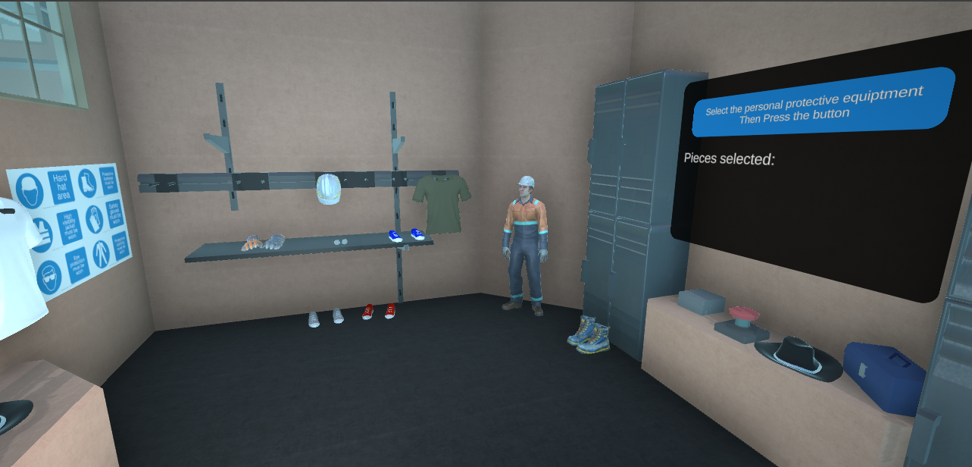

(Image of the locker room, showing its appearance before feedback)

After a few playtesting sessions this room was modified based on feedback from participants to make things clearer, the new room incorporated coloured safety glasses to make them stand out more and be clearer that they are the correct answer.

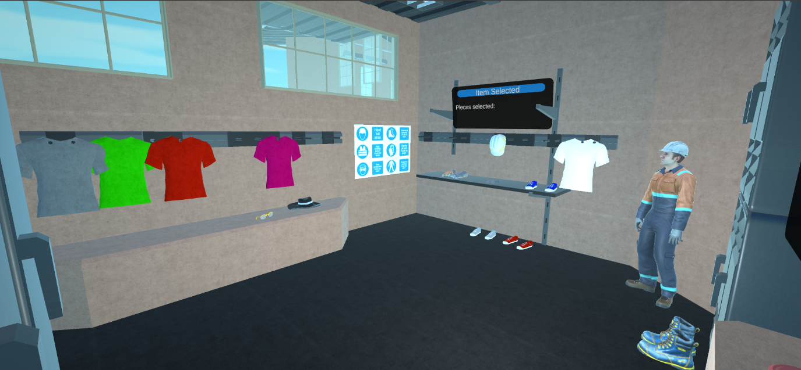

(Image of the locker room, showing its appearance after feedback)

#### Manual handling activity – **Understand** – **Apply**

Objective: To demonstrate comprehension of proper manual handling techniques and apply this knowledge in a simulated environment.

This module spans two cognitive levels of Bloom's Taxonomy: "Understand" and "Apply." It begins with comprehension of correct bending and lifting techniques, then progresses to the application of this knowledge in a simulated task environment.

The progression from understanding to application aligns with Bloom's Taxonomy, facilitating deeper learning (Anderson et al., 2001). The practical application phase incorporates principles of situated learning theory (Lave & Wenger, 1991), allowing participants to apply knowledge in a contextually relevant environment, which is designed to reflect a warehouse.

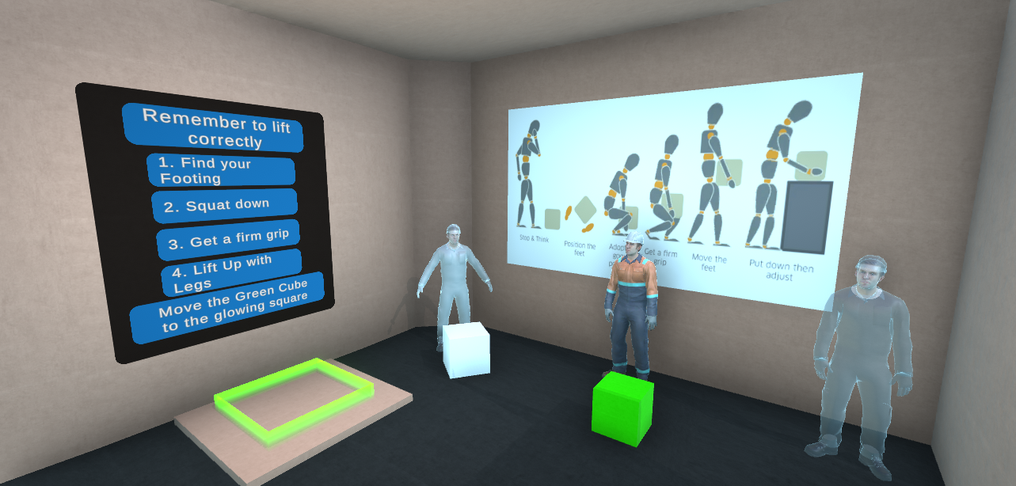

(Image of the manual handling room, showing its appearance)

This situation was designed to get the player moving and preforming the safe lifting methods, through observation. I included using lifting equipment such as pallet loaders, to make the project more interactive and to demonstrate that not all objects can be lifted by hand.

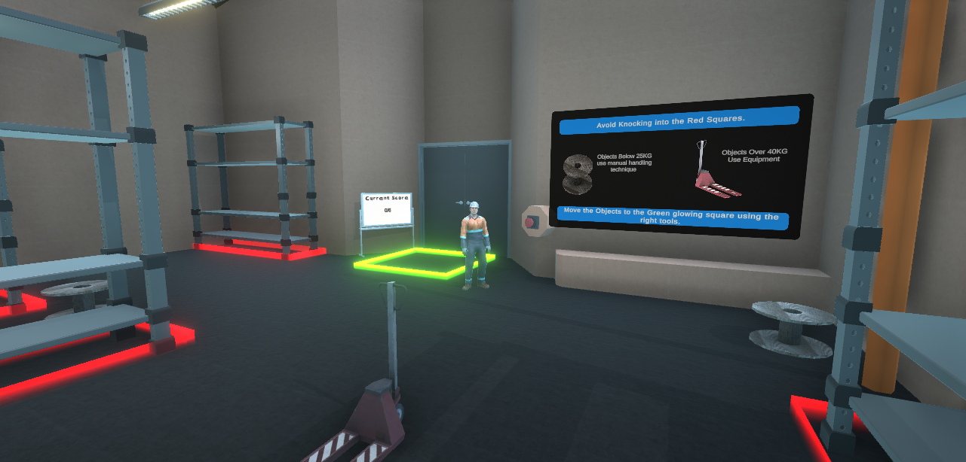

(Image of the manual handling activity room, showing its appearance)

This section takes a step further in the bloom taxonomy not just understanding what is required but applying it in the simulation, getting the player involved directly in the more interactive section of the modules shows understanding when they use the pallet loaders since they can’t lift it directly.

One thing I would have liked to include was using the equipment like how a person would normally, I had to abstract it into just grabbing and moving. Which is not what it is like, this might present a problem and a goal for future development.

#### Manual handling quiz - **Remember**

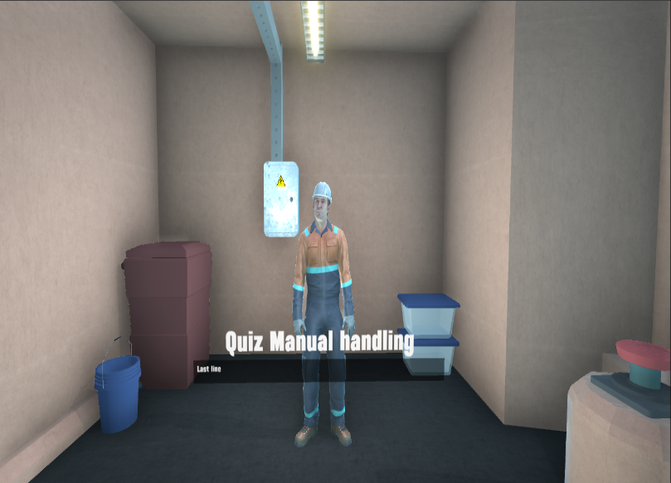Separate to the manual handling activity is the manual handling quiz, this quiz reinforces what the player has learned from the manual handling activity.

The goal of this task is for the player to correctly select the appropriate answers to see if they remembered important information from the activity.

One thing I believe might be an issue is the small clickable answers which might present a problem with VR controls.

(Image of the manual handling quiz room, showing its appearance)

#### Ladder safety - **Evaluate**

Objective: To assess participants' ability to evaluate ladder setups for safety compliance in various scenarios.

This module targets the "Evaluate" level of Bloom's Taxonomy, requiring participants to make judgments based on criteria and standards. Participants must assess different ladder setups and determine their safety and compliance with regulations.

This module was designed to make the player think about how ladders setups have been placed in different conditions as using ladders has one of the highest risks (Hse.gov.uk, 2023).

This task leverages the capabilities of VR to present scenarios that would be impractical or dangerous to replicate in real-world training (Suh & Prophet, 2018). The evaluation process engages higher-order thinking skills, aligning with the upper levels of Bloom's Taxonomy (Anderson et al., 2001). The task structure incorporates elements of case-based learning, which has been shown to enhance critical thinking and decision-making skills (Belland, Brian et al, 2013).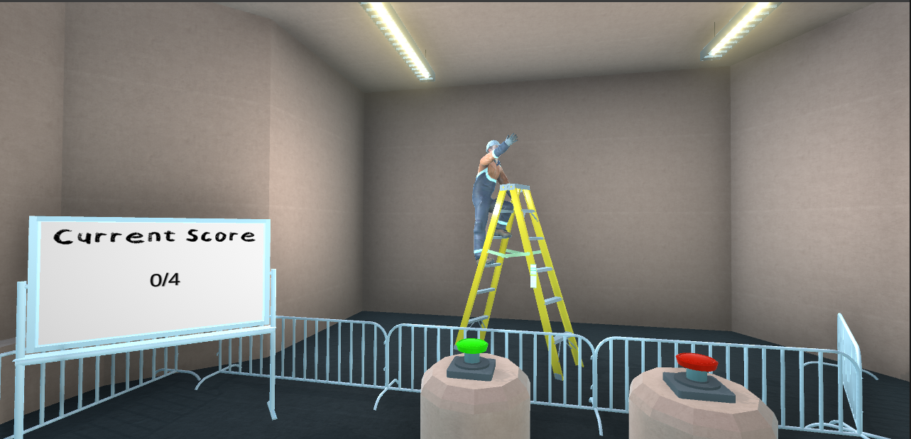

(Image of the ladder safety room, showing off a situation)

#### Riser awareness – **Apply**

Objective: To apply knowledge of riser room safety protocols in a simulated environment.

This module focuses on the "Apply" level of Bloom's Taxonomy, requiring participants to execute learned procedures in a new situation. Participants must identify potential hazards and apply safety protocols in a simulated riser room environment.

In larger buildings there normally is a room called the riser which is a room where all of the main supplies run up, this room has a high degree of risk associated with it. Before the player starts the task for the module they are told about the dangers associated with risers and some rules about entering.

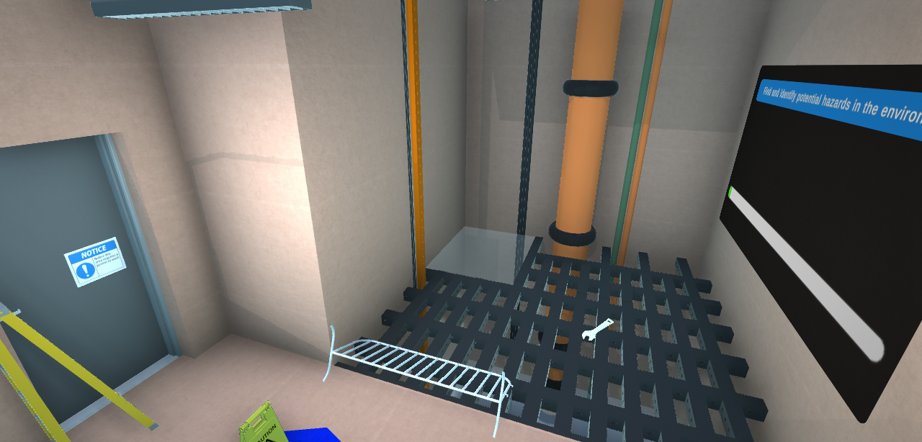In this module the player is tasked with ensuring that the room is safe, by highlighting the dangers and the conditions to enter the room as they do this the room is returned to a safe state.

(Image of Riser safety room)

### GRP Riser Covers Dura Composites | blog.pethucos.com.brVisual design

When designing the environment and activities, I had to keep in mind the limitations of VR along with minimizing the associated risks with VR. One limitation of VR is the number of polygons that can be displayed without slowing down the simulation, I encountered a problem while developing the project it wouldn’t build. I later realised that the problem was an overload in the number of polygons being rendering before play, to keep the count down, I manually removed polygons from models, and I used simple shapes to maximize the amount I could use for more important objects. However, this did mean I couldn’t place as many objects to decorate the simulation as I would have liked, which could make it seem less lived in and therefore less realistic.

One common method I implemented was a soft fading out when moving between rooms, this has been shown to reduce the motion sickness with VR(Irving, 2016**)** rather than just jumping to a new view, another method was using a consistent visual cue, where only objects that are highlighted by the player glow, and including colour coding objectives that are either green or red. Avoiding having sharp contrasting colours has been shown to reduce eye strain

(Color With Leo, 2023).

I have incorporated icons and labels in the relevant rooms for the player to look at as a fallback method; to help them to complete the task, the design of the icons are matches of what will be in a real worksite.

### Feedback mechanisms

In addition to all the boards displaying the objective and current score in each of the activity’s rooms, the rooms included physical feedback showing that objects are interactable, or sound cues for objectives completed or failed (Cooper et al., 2021), this gives immediate notice to the player that they are performing a task correctly or incorrectly.

I made sure that the interactions were standardised which used consistent control schemes, to help the player reduce the cognitive load of the technology, and to provide constant experience through the modules.

## Results

The sample size as previously mentioned is going to be a small sample size however this could be seen as a preliminary study into seeing whether there is potential in this type of technology for learning.

The demographics were relevantly broad for the type of technology and subject, 50% were aged 18-24 while 45-56 were 25%

This included industry professionals and younger non construction professionals.

37.5% had no experience with VR before this application while 50% rated themselves as beginner said they heard and have used the technology before.

This reduced experience might have had a result on how well they able to interact with the project.

The majority of those that put their job title in the form had a connection with at least one module of the simulation most likely the manual handling section since this is a common aspect of hands-on jobs.

Most people who participated self-identified their learning style as kinaesthetic learners

For the broad overall design questions, they were graded on a 7-point scale this number was chosen so that testers could give a neutral/balanced view.

* What did participants think of how easy it was to interact with the application?

The average score was 4.63. with the most common score being 5 with the lowest being 3. 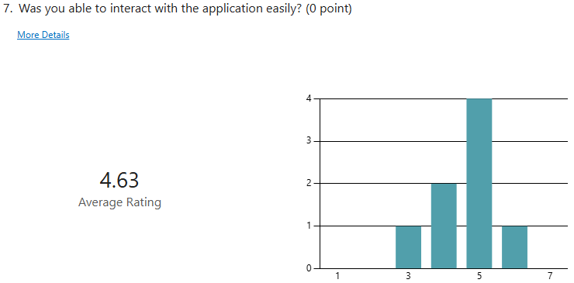This does show that there were issues with the controls and certain interactions, looking into some of the qualitative the most highlighted issue was that the hand controller was “glitchy” and it was hard to aim at objects. Future development of the project would need to address those issues and provide a more stable aiming control.

* What did the participants feel about having immediate feedback on their score?

The average score was 5. 4 and 6 were the most common answers.

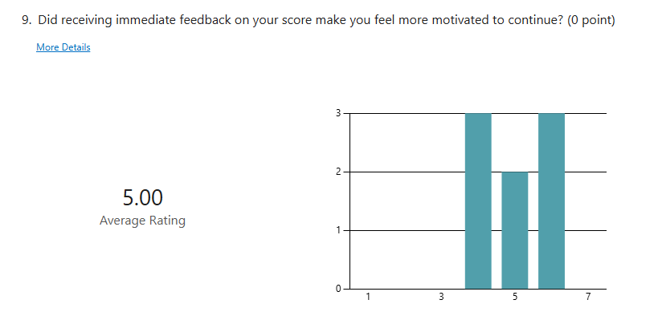

This graph is interesting since it’s the only chart that doesn’t have a standard bell curve; it’s more bimodal. This suggests that there might be multiple factors influencing the distribution. The concentration of scores around 4 and 6 indicates a split in participants' opinions about immediate feedback on their performance. This divide could be attributed to various factors, such as individual preferences for learning styles, prior experiences with gamified learning, or differing levels of comfort with technology. however, this also demonstrates that the absence of extreme scores (1 or 7) indicates that while opinions varied, participants generally found value in the feedback system and that it was motivating.

* What did participants think of how realistic and practical the scenarios were in the simulation

The average score was 5.63. 7 out of 8 the participants gave the score above the average. 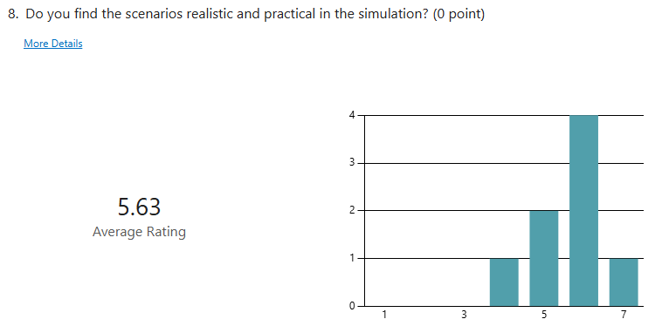

This shows that the participants found the scenarios to be relatively realistic and practical but there is room for improvement. This is a good result and shows that the application has potential, in the actual scenario learning expectation.

* What did participants think of how immersive the simulation experience was.

The average was 5.50. with the common score being 5. With the highest being two 7’s and the lowest being a 3.

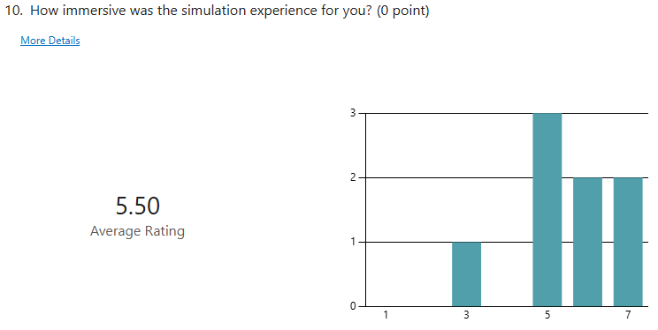

This score indicates that the application was kind of immersive, this lean to towards the higher score could be in part due to the novity of the VR application among the non-experienced VR people however the low score indicates that there was something that broke the immersion. From the participant ID feedback, their feedback was that their major issue was the control being jittery.  
  
For the questions that arise while developing.

1. What learner type responds best to VR-based learning?

Most participants self-identified as kinaesthetic learners. This aligns well with the nature of VR-based learning, which is naturally interactive and involves physical movement. kinaesthetic learners were generally more positive in their responses which suggest that VR-based learning may be particularly effective for this learning style. This makes sense given that VR allows for hands-on, immersive experiences that align well with kinaesthetic learning preferences. Although the extremely low sampling size may have bias and a larger study should really be done to see if this is the case.

1. Are players aware of the different levels of cognitive complexity?

Participants were generally aware of what the correct level of cognitive complexity however towards the higher level of cognitive there was a tendency to less confidence.

With the PPE Module (Remember) most participants correctly identified this as "Remembering" which shows good awareness of the basic cognitive level.

Manual Handling (Understand/Apply): Responses varied between "Understanding," "Applying," and "Evaluating," indicating some awareness of the higher cognitive demands but also some uncertainty. This didn’t include evaluating any situations however the use of switching between tools may have led the participants to believe that they are evaluating what tool to use. While in fact they are understanding that they cant lift certain objects and applying what they have been told.

Ladder Safety (Evaluate): The responses included "Analysing" and "Evaluating," suggesting that participants understood that the higher-order thinking was required, even if they didn't always use the exact term. This could be because they were both analysing the situation and evaluating however this type of situation used a basic yes or no which leads it towards more of simple evaluating.

Riser Awareness (Apply): Responses were mixed included "Understanding," "Applying," and "Analysing," showing a range of perceptions around the cognitive level required. This module was the least correctly identified, possibly due to its design. While intended to apply knowledge from the introductory talk, the task of identifying hazards could be misconstrued as understanding or analysis. This mistake highlights the challenge of clearly distinguishing cognitive levels in immersive learning environments, where the boundaries between understanding, application, and analysis can become blurred.

This demonstrates that participants did have some understanding of the increasing levels of cognitive intensity, future research could look into tailoring learning experiences towards individuals.

## CONCLUSION:

Based on the research conducted and the results attained, this study suggests that the integration of Goal-Setting Theory into an immersive virtual reality (IVR) environment for site safety training shows promising potential for enhancing learning.

The findings indicate that there are several advantages of this approach over traditional training methods, however there are some issues that need to be addressed before such can be develop.

Looking into the results the IVR environment provided a realistic and practical simulation of workplace scenarios, scoring an average of 5.63 out of 7 for realism and practicality. This immersive quality allows learners to experience and interact with potential hazards in a safe, controlled environment. Furthermore, the overall immersive experience scored 5.50 out of 7, indicating that participants found the VR-based learning engaging. That engagement is crucial for maintaining learner attention and improving knowledge retention.

The incorporation of immediate feedback on performance, a key principle of Goal-Setting Theory, was generally well-received, with an average score of 5 out of 7. This aligns with the theory's emphasis on clear progress indicators and motivation for improvement. Additionally, participants demonstrated some awareness of the different levels of cognitive complexity in the tasks, particularly at lower levels. This suggests that the design successfully incorporated varying levels of cognitive engagement, potentially leading to more comprehensive learning outcomes.

Interestingly, our study found that the participants that self-identified as kinaesthetic learners, generally responded more positively to the VR-based learning. This indicates that IVR may be particularly effective for hands-on learners who benefit from physical interaction and experiential learning.

However, our research also revealed areas for improvement. The average score of 4.63 out of 7 for ease of interaction suggests that there is room for enhancing the user interface and control mechanisms. Some participants reported issues with "glitchy" hand controllers and aiming difficulties. Additionally, while participants generally recognized different levels of cognitive engagement, there was some confusion at higher levels. This indicates a need for clearer design and communication of cognitive objectives within the IVR environment.

It is important to note the limitations of this study, particularly the small sample size, which restricts the quality of the findings. A larger-scale study would be beneficial to confirm and expand upon these initial results.

In conclusion, our research suggests that the integration of Goal-Setting Theory into IVR for site safety training shows promise in creating an engaging, effective, and immersive learning experience. It appears particularly well-suited for kinaesthetic learners and offers unique advantages in simulating real-world scenarios safely. However, further development is needed to refine the user interface and clarify cognitive objectives.

Future research directions should include larger sample sizes and more complex modules to provide more definitive insights into the effectiveness of this approach compared to traditional training methods. Additionally, investigating the long-term retention of safety knowledge and its transfer to real-world situations would be valuable. Exploring the potential of adaptive IVR systems that can tailor the learning experience to individual learning styles and cognitive levels could also yield interesting results.

This study lays a foundation for the potential of IVR in revolutionizing safety training in various industries. As technology continues to advance, the integration of pedagogical theories like Goal-Setting Theory with immersive technologies may pave the way for more effective, engaging, and personalized training experiences in the future.

## REFERENCES: #

Abt, C.C., 1987. Serious games. University press of America.

Anderson, L.W., and Krathwohl, D.R., et al (eds.) (2001) ‘A Taxonomy for Learning, Teaching, and Assessing: A Revision of Bloom’s Taxonomy of Educational Objectives’, New York: Longman.

Ayoung Suh, Jane Prophet, 2018, The state of immersive technology research: A literature analysis, Computers in Human Behavior, Volume 86 , Pages 77-90, ISSN 0747-5632, https://doi.org/10.1016/j.chb.2018.04.019.(<https://www.sciencedirect.com/science/article/pii/S0747563218301857>)

Belland, Brian & Kim, Chanmin & Hannafin, Michael. (2013). A Framework for Designing Scaffolds That Improve Motivation and Cognition. Educational psychologist. 48. 243-270. 10.1080/00461520.2013.838920.

Bloom, B.S. (ed.) (1956) ‘Taxonomy of Educational Objectives, the classification of educational goals – Handbook I: Cognitive Domain’, New York: McKay.

Bruckman, A.: Can educational be fun? In: presented at the Game Developers Conference 1999, San Jose, CA (1999). [http://www.cc.gatech.edu/~asb/papers/bruckman-gdc99.pdf](http://www.cc.gatech.edu/%7easb/papers/bruckman-gdc99.pdf)

Gee, J.P., 2003. What video games have to teach us about learning and literacy. Computers in entertainment (CIE), 1(1), pp.20-20.

Cooper N, Millela F, Cant I, White MD, Meyer G (2021) Transfer of training—Virtual reality training with augmented multisensory cues improves user experience during training and task performance in the real world. PLoS ONE 16(3): e0248225. https://doi.org/10.1371/journal.pone.0248225

Csíkszentmihályi, M. Beyond boredom and anxiety. Jossey-Bass Publishers, San Francisco, 1975

Color With Leo (2023) *What color is least damaging to eyes?*, *Color With Leo*. Available at: https://www.colorwithleo.com/what-color-is-least-damaging-to-eyes/ (Accessed: 07 August 2024).

Donovan, D. (2018) *10 case studies: Learn How VR enhances training: Interplay*, *Interplay Learning*. Available at: https://www.interplaylearning.com/blog/virtual-reality-increases-training-effectiveness-10-case-studies/ (Accessed: 07 August 2024).

D. W. Carruth, "Virtual reality for education and workforce training," 2017 15th International Conference on Emerging eLearning Technologies and Applications (ICETA), Stary Smokovec, Slovakia, 2017, pp. 1-6, doi: 10.1109/ICETA.2017.8102472.

Hafsia, M., Monacelli, E. and Martin, H., 2024. Virtual Reality Simulator for Construction Workers. International Journal of Construction Education and Research,

Hse.gov.uk. (2023). *Statistics - Work-related fatal injuries in Great Britain*. [online] Available at: https://www.hse.gov.uk/statistics/fatals.htm#:~:text=workers%2C%202023%2F24- [Accessed 1 Sep. 2024].

‌

Irving, M. (2016) *Restricting field of view to reduce motion sickness in VR*, *New Atlas*. Available at: https://newatlas.com/columbia-university-vr-motion-sickness/43855/ (Accessed: 07 August 2024).

Karakose, T., Polat, H. and Papadakis, S. (2021), “Examining teachers’ perspectives on school

principals’ digital leadership roles and technology capabilities during the COVID-19 Pandemic,

Sustainability, Vol. 13 No. 23, p. 13448

Ketamo, H. & Kiili, K. (2010). Conceptual change takes time: Game based learning cannot be only supplementary amusement. Journal of Educational Multimedia and Hypermedia, vol. 19(1)

Kolb, D. A. (1984). Experiential learning: Experience as the source of learning and development (Vol. 1). Englewood Cliffs, NJ: Prentice-Hall.

Kolb, David & Kolb, Alice. (2013). The Kolb Learning Style Inventory 4.0: Guide to Theory, Psychometrics, Research & Applications.

Locke, E. A., & Latham, G. P. (2015). Breaking the Rules: A Historical Overview of Goal-Setting Theory. In A. J. Elliot (Ed.), Advances in Motivation Science (Vol. 2, pp. 99-126). Elsevier. <https://doi.org/10.1016/bs.adms.2015.05.001>

Moseley, A., & Whitton, N. (Eds.). (2013). New Traditional Games for Learning: A Case Book (1st ed.). Routledge. <https://doi.org/10.4324/9780203597514>

Nakamura, J. and Csikszentmihalyi, M. The Concept of Flow.In C. R. Snyder and S. J. Lopez, eds., Handbook of positive psychology. Oxford University Press USA, New York, NY, USA, 2002, 89-105.

Ott, Michela & De Gloria, Alessandro & Arnab, Sylvester & Bellotti, Francesco & Kiili, Kristian & Freitas, Sara & Berta, Riccardo. (2011). Designing serious games for education: From pedagogical principles to game mechanisms. Proceedings of the European Conference on Games-based Learning. 2011.

Pather, N., Blyth, P., Chapman, J.A., Dayal, M.R., Flack, N.A., Fogg, Q.A. and Lazarus, M.D. (2020),

“Forced disruption of anatomy education in Australia and New Zealand: an acute response to

the covid-19 pandemic”, Anatomical Sciences Education, Vol. 13 No. 3, pp. 284-300.

Purdue Envision Center (2019) *OSHA Fall Safety VR Training Simulator - Introduction*, *YouTube*. Available at: https://www.youtube.com/watch?v=3Eksbi2H4fY (Accessed: 07 August 2024).

Sentient (2016) *Virtual Reality Demo for Safety Training - Working at Heights*, *YouTube*. Available at: https://www.youtube.com/watch?v=e5EEpvRedso (Accessed: 07 August 2024).

Sitterding, M. C. (2019). Virtual Reality Training in Nursing: A New Approach to Enhancing Clinical Skills. Journal of Nursing Education.

Vats, S., Joshi, R. (2024). The Impact of Virtual Reality in Education: A Comprehensive Research Study. In: Sharma, S.K., Dwivedi, Y.K., Metri, B., Lal, B., Elbanna, A. (eds) Transfer, Diffusion and Adoption of Next-Generation Digital Technologies. TDIT 2023. IFIP Advances in Information and Communication Technology, vol 699. Springer, Cham. https://doi.org/10.1007/978-3-031-50204-0_11

Wilson , L.O. (2020) Bloom’s taxonomy revised, https://thesecondprinciple.com. Available at: https://thesecondprinciple.com/essential-teaching-skills/blooms-taxonomy-revised/ (Accessed: 09 June 2024).

Zainuddin, Zamzami & Alba, Amru & Gunawan, Taufik & Armanda, Dicky & Zahara, Ana. (2022). Implementation of gamification and bloom’s digital taxonomy-based assessment: a scale development study with mixed-methods sequential exploratory design. Interactive Technology and Smart Education. 20. 10.1108/ITSE-02-2022-0029.